Lowestoft Sixth Form College: Scholarships

Lowestoft Sixth Form College scholarships are designed to provide additional funds to enable students to enrich and extend their learning through travel, additional qualifications and research. The scholarships take the form of a grant of £250 per academic year.

MISSION: To enable our students to excel and progress beyond expectation in an outstanding learning environment in the heart of Lowestoft
Applications are invited from students who:
- will be aged 16 on August 31st 2019
- are taking at least 7 GCSEs in Summer 2019
- are predicted to achieve outstanding GCSE results, mainly grades 7, 8 and 9, with a minimum of 2 grade 8’s and 5 grade 7’s
- will be enrolling to study at Lowestoft Sixth Form College
- are willing to make a wider contribution to College life

Application Process
Please complete an application form and a personal statement.
If you have already made an online application and accepted a place at Lowestoft Sixth Form College, you need only submit a personal statement.
Applications must arrive by noon 15.04.19
Send your completed application by hard copy or email to:
Kevin Grieve
Principal
Lowestoft Sixth Form College
Rotterdam Road
Lowestoft, Suffolk
NR32 2PJ
Email: c.gibbs@lowestoftsfc.ac.uk

The outcomes of the selection process will by advised by 03.05.19
Awards will be conditional upon GCSE performance and confirmed in September 2019
The decision of the Principal is final in matters relating to the award of scholarships.

If you have any problems completing the forms, require them in a different format or have any other queries please contact: Coral Gibbs, PA to Principal (Tel: 01502 537000)
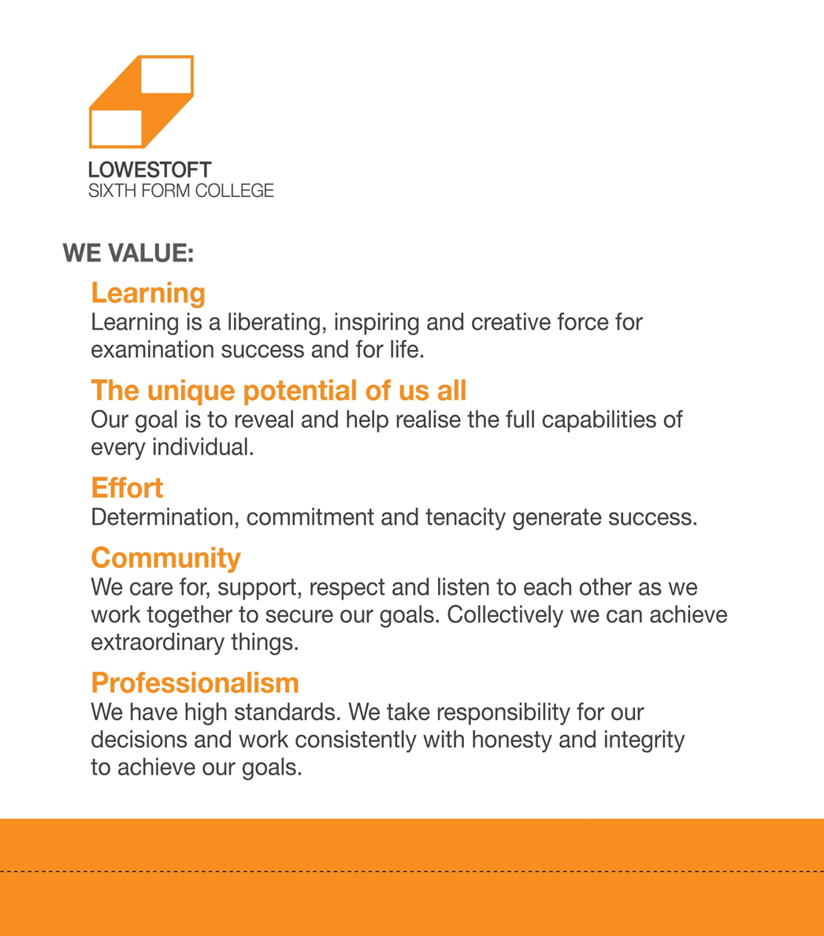
WWW.L6FC.ORG

Scholarship Application Form

FULL NAME (Applicant)
ADDRESS
TOWN
COUNTY
POSTCODE
TELEPHONE
EMAIL

Name of Parent/Guardian
ADDRESS
(if different from above)
TOWN
COUNTY
POSTCODE
TELEPHONE
EMAIL

Name of Current School
ADDRESS
TOWN
COUNTY
POSTCODE
Name of Head Teacher or
other Academic Reference
Please provide contact details of referee named above
Summer 2018: Predicted grades of GCSE subjects to be taken

 | Subject | Predicted/Achieved Grade | Date
1 | English Language
2 | Mathematics
3
4
5
6
7
8
9
10
11
12

September 2018: What AS/A-level or BTEC subjects do you hope to study?

Subject/Course
1
2
3
4

Scholarship Application - Personal Statement

NAME
Personal Statement: In no more than 500 words tell us why you think you should be considered for a scholarship. We are interested to learn about you and your interests, why you have chosen the subjects you have and your ambitions for the future. What will you add to College life?
Please write no more than 500 words
Please continue overleaf/on a blank continuation sheet if necessary

